CONFERENCE MENU PACKAGES

Available in GF - Gluten Free V –Vegetarian v -vegan
MORNING TEA MENU OPTION 1 $38.00 min 50 people
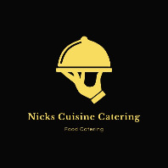 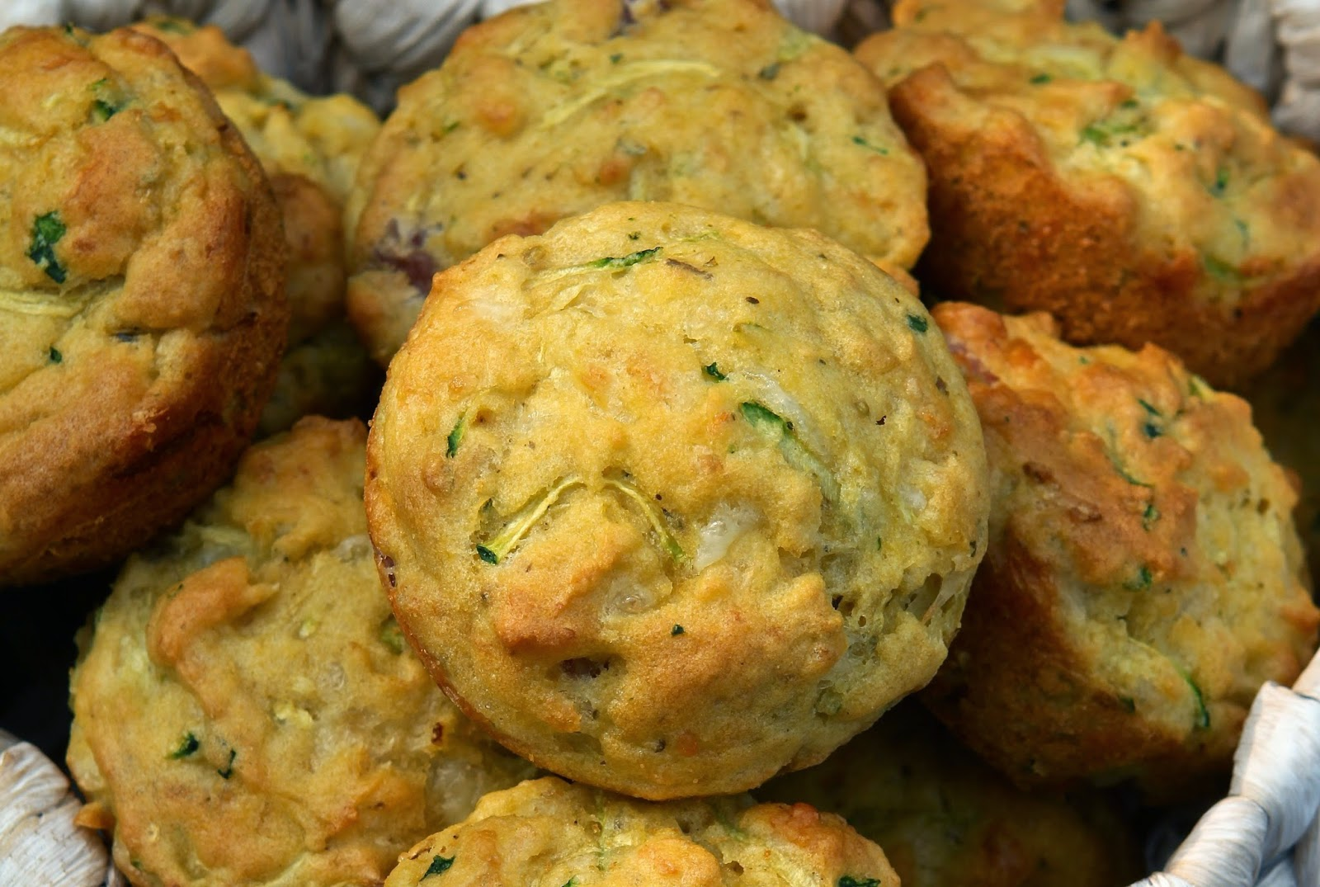 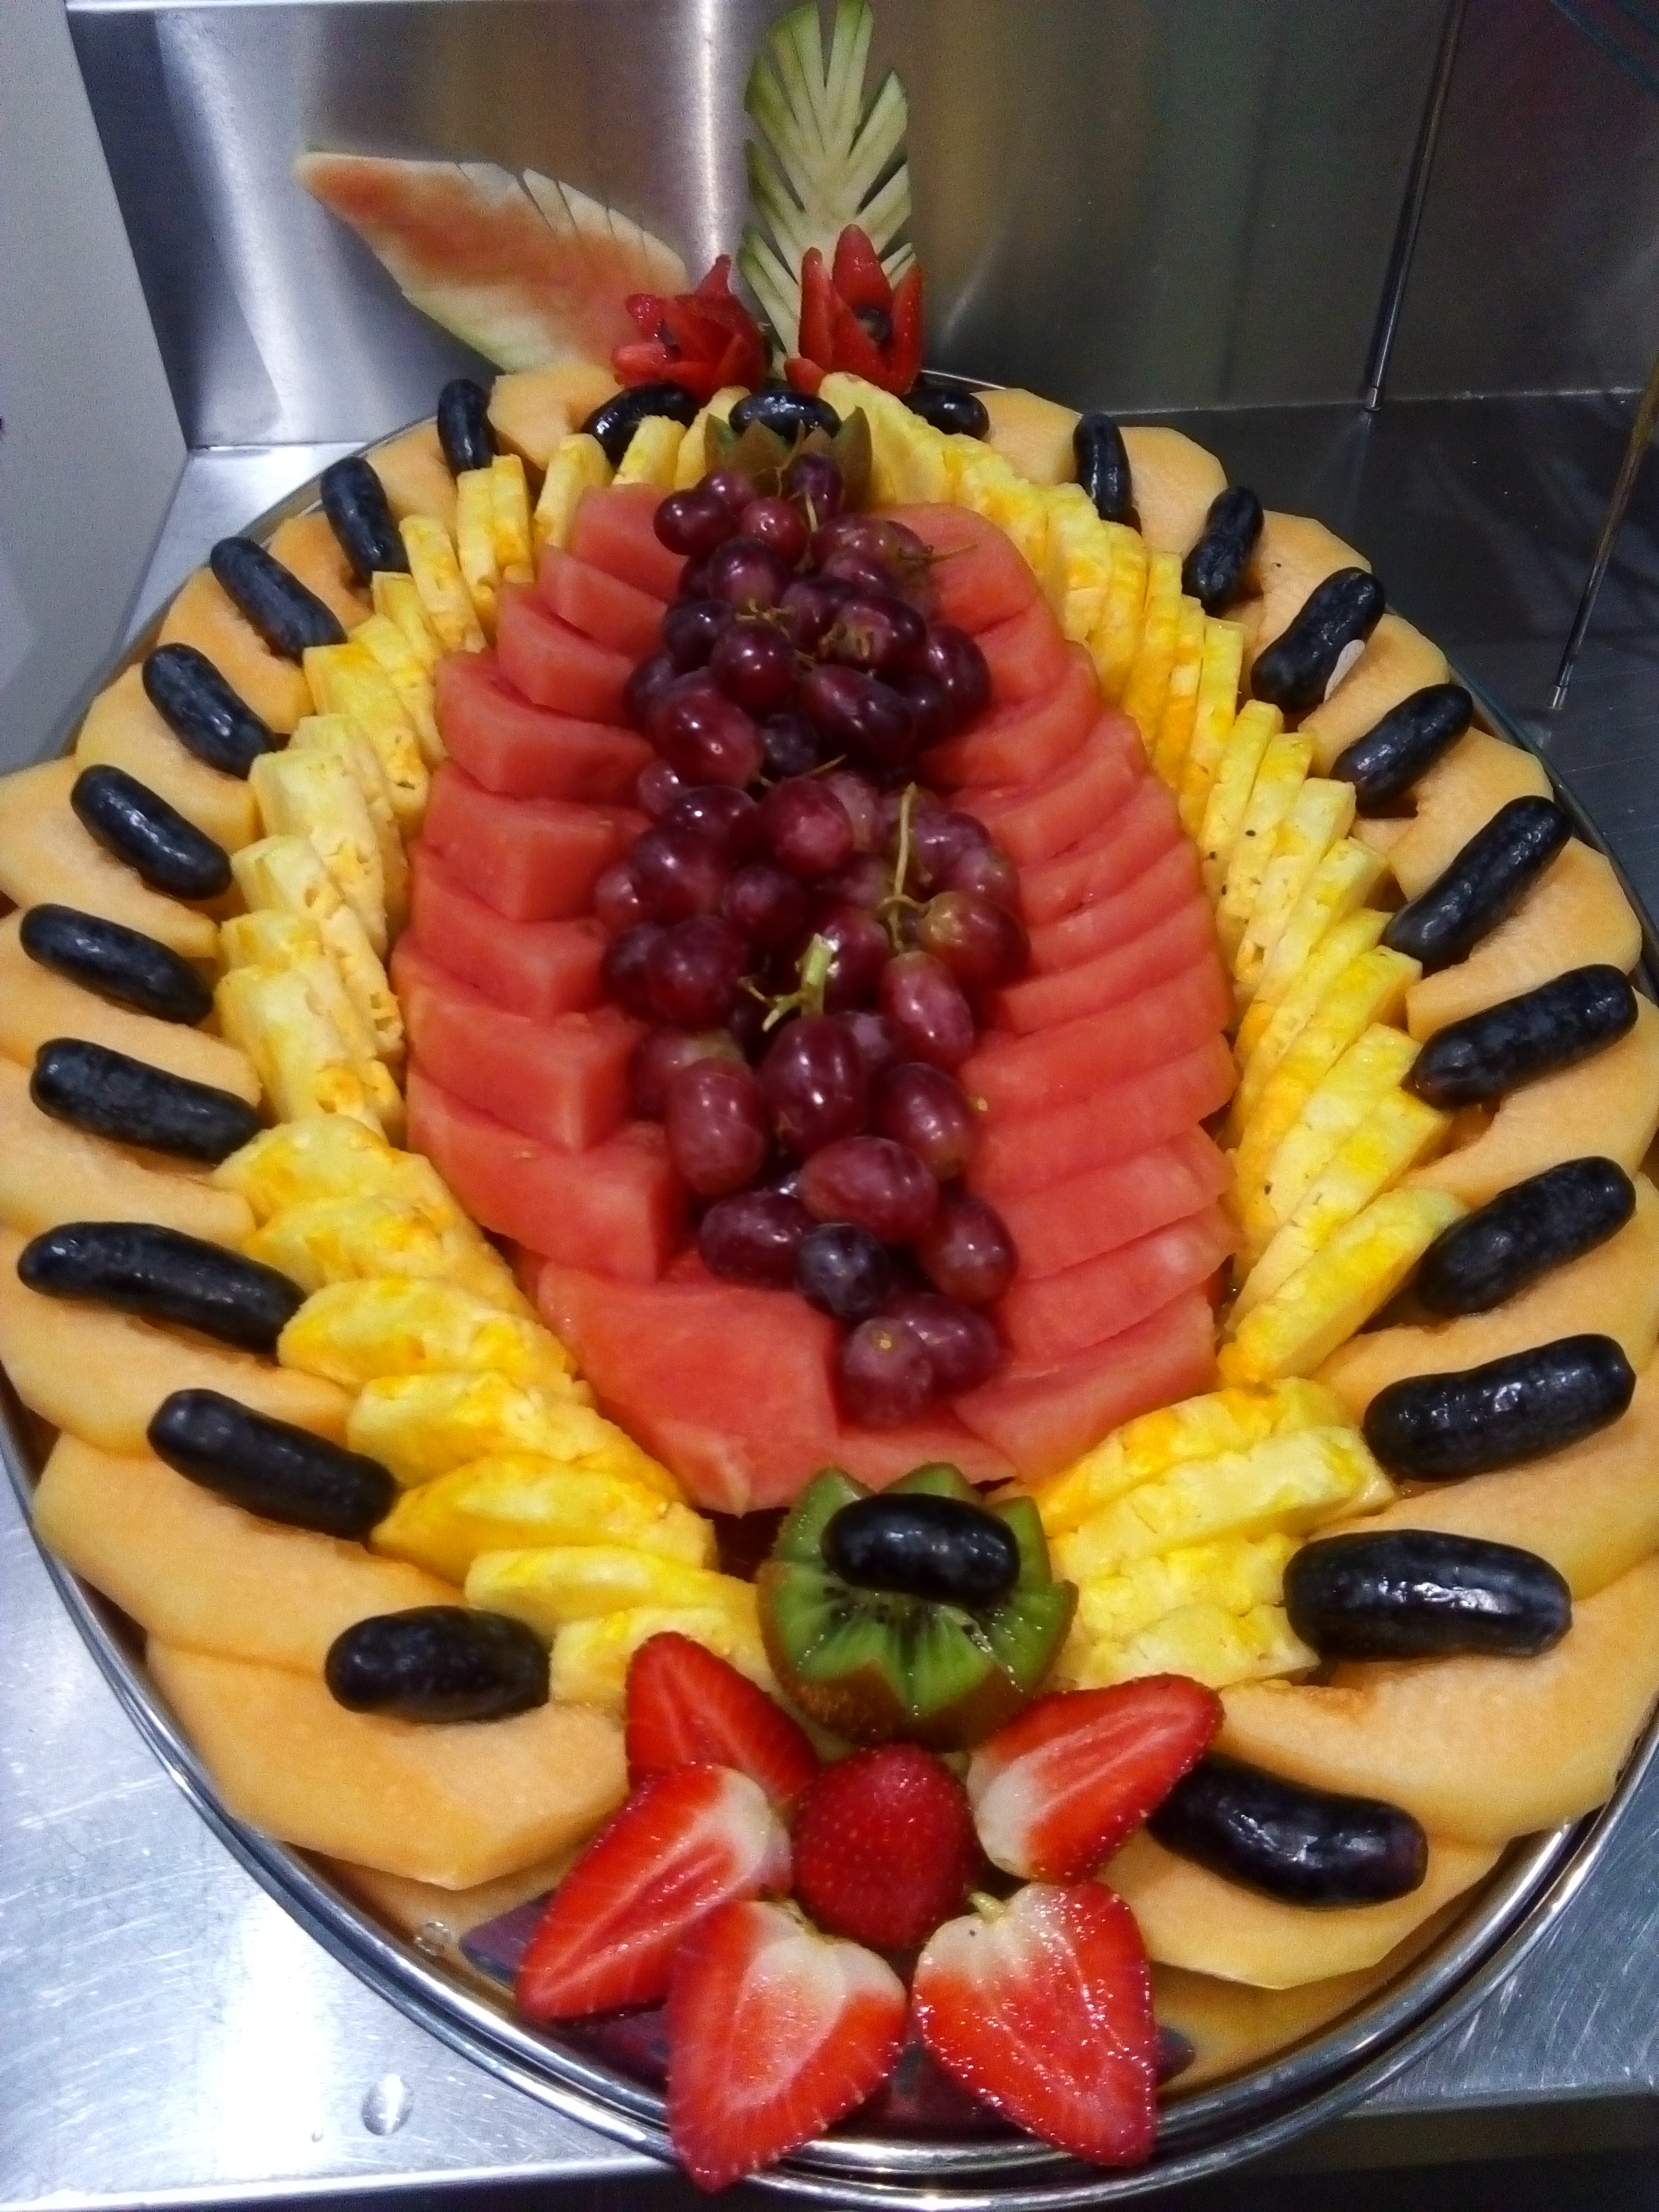
Freshly baked in-house muffins with spinach ricotta & fetta or bacon cheese & chives
Yoghurt pots a simple sweet yoghurt topped with toasted gluten free muesli and fresh berries GF V
Zucchini goats cheese frittata GF V or bacon spinach garlic frittata GF
Fresh marble cake and carrot cake

LUNCH
Gourmet Sandwiches
Flavour include Chicken schnitzel with mayo lettuce cheese. Turkey Cranberry and Brie Cheese, Champagne Ham hollandaise tomato cheese. Vegetarian with Pesto, Fetta and Roasted capsicum.
Omelete Bites (GF, V)
Roasted Vine ripened trussed tomatoes capsicums Danish fetta, fresh herbs and freerange eggs
Freshly Baked Scones (V)
A favourite fresh baked scones accompanied by strawberry jam and fresh whipped cream.
Fruit Bowls (GF, V, v)
A selection of whole seasonal fruits
100% Orange Juice, Iced Water, Tea and Coffee (morning tea and lunch)
Milk Options include: Full Cream, Light Milk Lactose free and Soy Milk

MORNING TEA OPTION 2 $42.00 minimum of 50 people
A delight of salted caramel raspberry and chocolate and Oreo cupcakes
Bacon and egg breakfast muffins
Croissant boats with ham capsicum onion and cheese
filled Tropical Fruit Kebabs (GF, V, v)
Served on bamboo skewers using a selection of fresh seasonal fruit

LUNCH
Sliders and Gourmet Wraps (one serve pp)
Pulled pork with apple slaw sliders
Chicken fillets strips with lettuce avocado garlic ioli wraps
Beef burger with caramalised onion tomato sauce
Tomato rocket cos lettuce and feta cheese Wraps
Cheese and Fruit Platters (GF, V, v)
Our Chef’s selection of cheeses, which include double brie and camembert, Kings Island Smoked Cheddar, Danish Blue Brie and fresh dates apricots walnuts with seasonal fresh fruit, accompanied by crackers

AFTERNOON TEA
Gourmet Cookies including Anzac, monte Carlo and scotch finger.
Peaches and cream rice pudding
Fresh inhouse mini chocolate and vanilla spirals
100% Orange Juice, Iced Water, Tea and Coffee (breakfast lunch afternoon tea)
Milk Options include: Full Cream, Light Milk and Soy Milk
All plates cutlery napkins glassware is included in price

MORNING TEA OPTION 3 $48.00 minimum of 50 people
Spinach cheese and egg bake
Only the finest ingredients create this baby spinach cheese free range eggs with fresh herbs
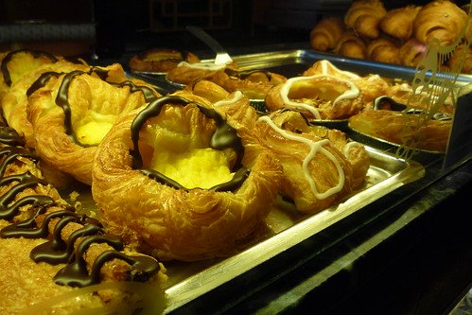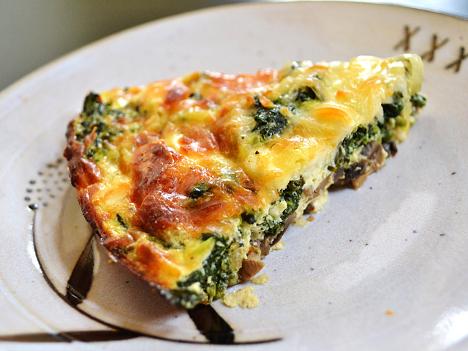
Danish Pastries and Savory pastries
A selection of fresh baked Danish pastries with fruit and custard fillings
Inhouse made sausage rolls and pies
LUNCH
Chef’s Selection of five Finger Foods
5 different finger food including chicken dim sims spring rolls prawn parcels coin bags samosa
Oriental Platter (GF, V, v)
Our freshly made Vietnamese sushi platter

AFTERNOON TEA
Cheese and Fruit Platters (GF, V)
Our chef’s selection of cheeses, which include double brie and camembert, kings Island smoked cheddar, Danish blue cheese dried fruit nuts accompanied by dips and crackers.
Tropical fruit platters
100% Orange Juice, Iced Water, Tea and Coffee (breakfast lunch and afternoon tea)
milk options: Full Cream, Light Milk and Soy Milk
All plates cutlery napkins glassware is included in price
Please Note: To have your catering delivered, a minimum of $150.00 is required on a weekday and a minimum order of $500.00 is required on a weekend.

