BEEF AND CHICKEN PARTY $39.95
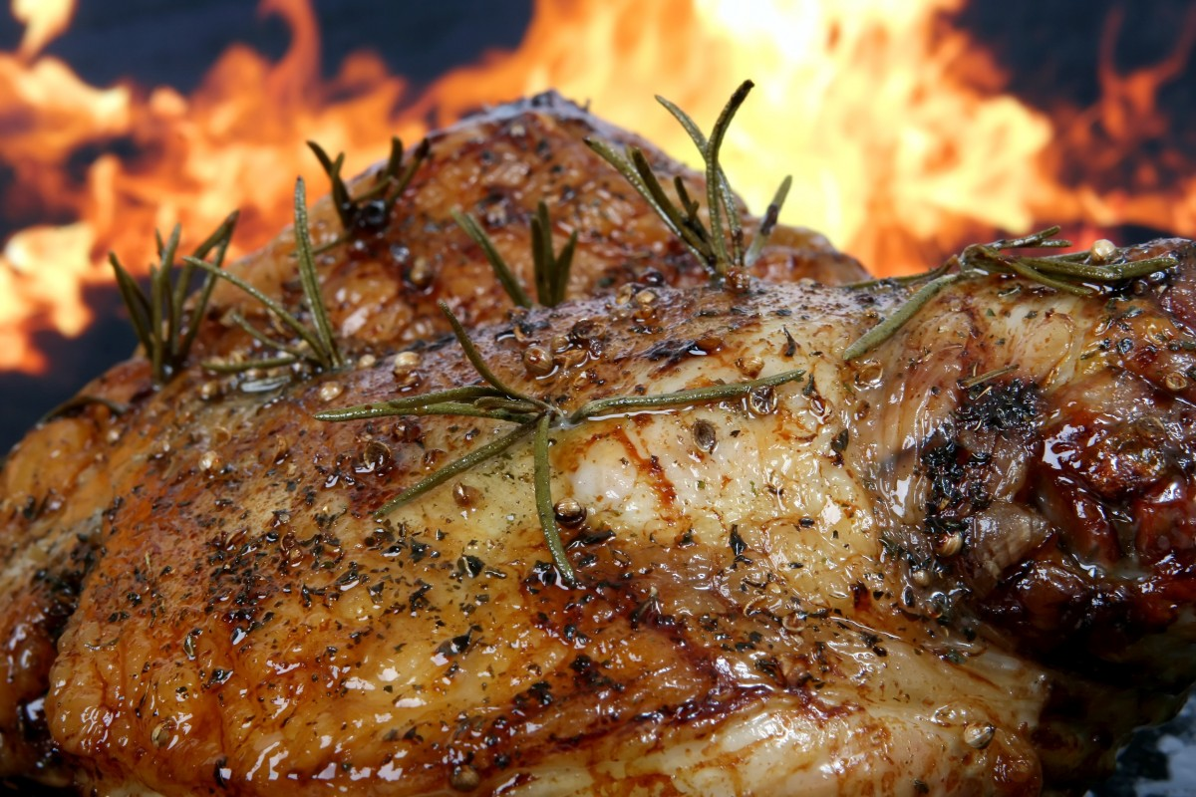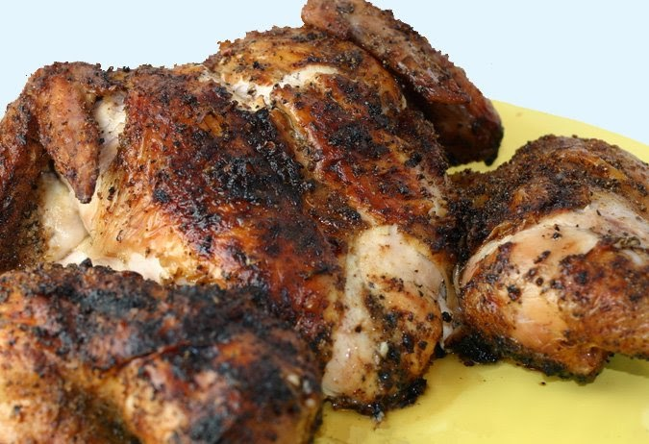
ENTRÉE (Choose one option)
Crispy pita breads with homemade dips
Antipasto platter
Savory Tuna salad served with Turkish bread pieces

Mains Menu options (Choose two option)
Delicious yearling seasoned Beef and gravy
Classic Beef stroganoff
Baked honey mustard corned beef
Roast seasoned chicken pieces
Creamy garlic herb chicken breast fillets
Char grill chicken with lemon mustard sauce

Sides (Choose two options)
Cracked pepper roast garlic and rosemary chat potato V GF
Oven roasted seasoned Vegies (potato pumpkin carrots sweet potato)
Fresh herbs oven baked roasted cauliflower with parmesan cheese V GF
Chicken penne pasta with bacon spinach special creamy sauce
Broccoli with bacon fried onions and cracked pepper GF
Cheesy garlic scalloped potatoes GF
Fresh chili garlic green beans V GF
Fried rice or steamed rice GF

Salad options (choose two)
Mediterranean Tortellini salad red white vinaigrette
Southern style potato salad V GF
Authentic Greek salad V GF
Chefs special cabbage salad
Beetroot and baby spinach feta salad V GF
Seafood crunchy salad V GF
Rainbow coleslaw V GF

Desserts Menu Options
Mini Oreo cheesecake V
Strawberry cheesecake puffs VGF
Vegan carrot cake V
Chocolate hazelnut mouse with fine swiss grated chocolate garnish VGF
Chefs special caramel pecan pie V
Chefs special chocolate éclair cake V
Wickedly good chocolate Tiramisu cake V
Tropical fresh fruit tart with orange custard cream V

Buffet menu price includes:
Set up and pack down all food and catering equipment (Buffet tables, chafers, warmers, plates, cutlery etc.
Full set up of buffet tables including cloth with skirting also including complimentary theme decorations
Condiments & dressings including salt & pepper shakers ready on serving station
Stainless steel cutlery, paper napkins, ceramic plates ready on serving stations
Uniformed staff for serving at Buffet station
Clear away all plates cutlery at guest tables
Bread and butter supplied in price

