INTERNATIONAL HOT BUFFET MENU

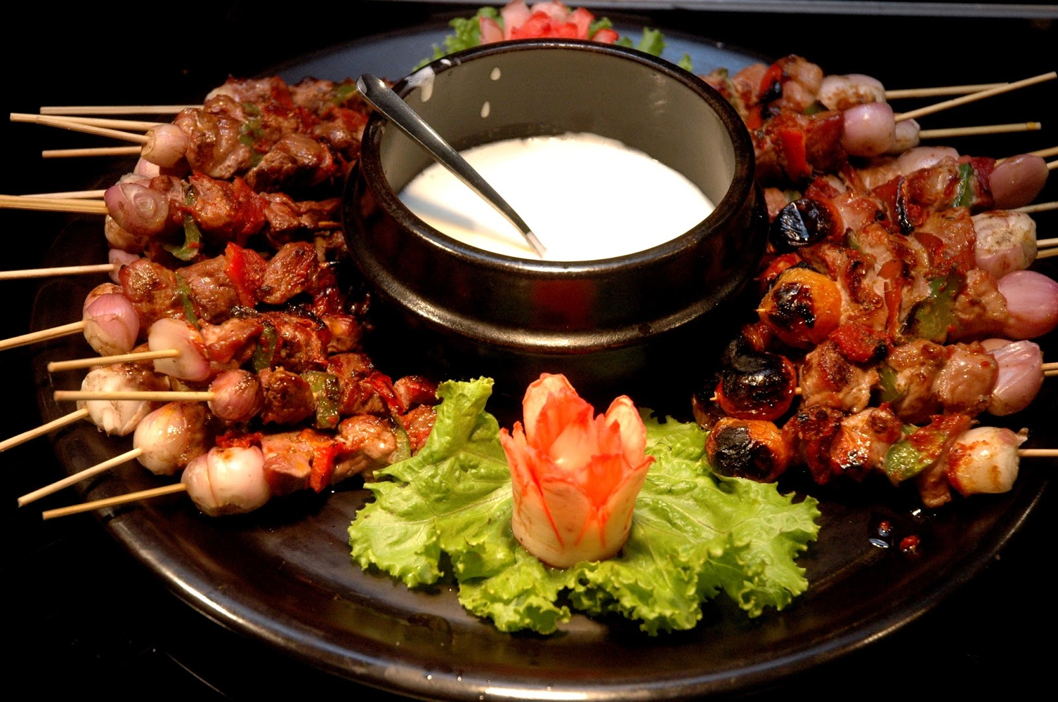

ENTRÉE (choose one option)
1. Entree Lasagne 2. Toasted Turkish bread pieces with dipping sauces 3. Asian chicken soup

MAINS (Choose Two options)
Honey Garlic Prawns with Broccoli –extra $5.00 per head
Coconut Curried Chicken with pumpkin
Thai Chicken Noodles or Vegetarian
Bistec Ala Mexicana GF
Lamb Korma
Authentic Pastitsio
Greek Style lamb shanks seasoned with lemon and herbed garlic fresh thyme GF
Chicken Parmigana
Spaghetti Alla Carbonara
Pasta Al Forno
Includes our Famous Combination Fried rice or steamed rice

Contact details 0422330571
Email:creativecateringbypoppy@gmail.com

SALAD OPTIONS (Choose two options)
Our Tuscan Tortellini Salad
Beetroot and Feta Bean and Baby Spinach Salad GF V
Mediterranean Tuna Salad GF
Chicken Caesar Pasta Salad
Broccoli Cauliflower Salad GF V
Potato Salad with no Mayo Fresh Herbs and Olive Oil Lemon Juice Mustard V
Traditional Potato Salad
Asian Noodle Salad
Italian Pasta Salad
Greek Salad in Vinaigrette dressing V GF
Moroccan Cabbage Salad V GF

DESSERTS OPTIONS (Choose three options)
English Banoffee Pie
Chefs special Chocolate Tiramisu Trifle
Baked Ricotta Cheesecake
Greek Traditional Mille Feuille
Halva with Samolina
Turkish Baklava Fistiki
Éclair au Chocolat
German Bienebstich (Bee Sting Cake)
Fruit Platters included in price
Tea and Coffee stations are added on dessert stations

