PLATTER OPTIONS
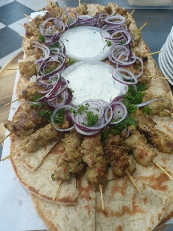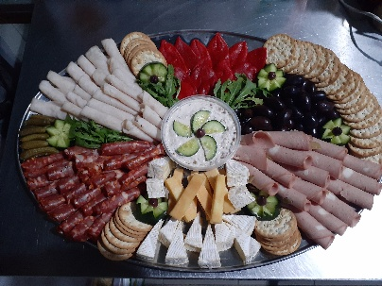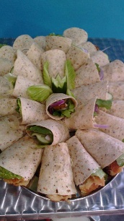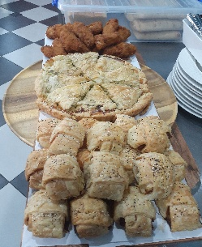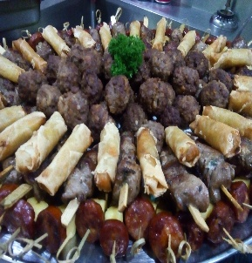
The Ultimate Chicken Platter
Chicken devil wing dings, garlic chicken balls, southern style strips, mini Thai satays, chicken spring roll and samosa.
Medium $90.00 serves (6-8) Large $120.00 serves (10-12)

Meat Lovers Platter
Flaming style meat balls, Lamb loin chops, Pork satay sticks, Italian sausages, seasoned wedges with Mexican sour cream or dipping of your choice .
Medium $95.00 serves (6-8) large $130.00 serves (10-12) Halal options are available by request

Savory Pastry Platter
Homemade spicy sausage rolls, chicken mushroom pie, spinach feta ricotta quiche wrapped sausage in puff pastry with cracked pepper.
Chorizo cheese semi dried tomato pastries.
Medium $65.00 serves (6-8) large $85.00 (10-12)

Deli Style Platter
Leg ham off the bone, salami sticks, kabana, cheese, kalamata olives, stuffed peppers, artichokes, cucumbers and cherry tomato, smoked dip of your choice and crackers or chargrilled Turkish bread.
Medium $90.00 serves (6-8) large $120.00 serves (10-12)

Vegetarian Platter
Char grilled vegetables, olives, cucumbers, cherry tomato two cheeses dolmathakia sweet potato chutney with small crostini breads or gluten free options
Medium $65.00 (6-8) Large $85.00 (10-12) V G

Cheese and Fruit Platter
Blue cheese, round brie cheese, cheddar cheese, dried fruit, seedless grapes, fresh dates sweet and spicy chutney with cheese crackers or gluten free crackers
Medium $85.00 (6-8) Large $105.00 (10-12) V G

Mediterranean Mezze Platter
Dolmathakia pickled octopus, artichokes, chargrilled eggplants, Kalamata olives, lamb with mint keftethes, tarama and tzatziki dips with toasted pita breads
Medium $85.00 (6-8) Large $120.00 (10-12)

Savory Sliders Platter
Cooked to perfection pulled pork sliders with special rainbow coleslaw with added garlic aioli
Medium $95.00 Large $125.00

Gourmet Mixed Wraps
Smoked trout wraps (smoked trout sour cream mayo thin cabbage rocket cos lettuce and dill
Mexican tortilla chicken wraps (chicken pieces with lettuce avocado corn tomato grated cheese)
Tuna wraps (tuna lettuce mayo Greek yoghurt celery red peppers green onion parsley lemon juice)
Medium $95.00 Large $125.00

Fritter Platter
Eggplant frittata (eggplant potato red onion green capsicums and feta)
Bacon and spinach Frittata (baby spinach bacon pieces mozzarella cheese and crushed fresh garlic
Medium $75.00 Large $95.00

Bruschetta Platters
Italian style (cherry tomato feta olives capers rocket) with drizzled garlic flavor olive oil)
Smoked salmon (smoked salmon feta avocado black pepper lemon juice)
Chorizo (semi dried tomato roasted capsicum grilled chopped chorizo tangy bbq sauce
Medium $65.00 Large $95.00

Skewer Platters
Greek style souvlaki sticks tzatziki pita bread wedges of lemon
Thai style satays with dipping with sauce seasoned rice on base of platter
Chicken bacon wrapped skewers lemon mustard sauce served french fries
Beef red wine and garlic skewers with capsicum onion mushroom
Grilled chorizo mushroom sliced potato skewers hot flaming sauce
Prawn skewers with grated lemon vest garlic and parsley butter
Medium $85.00 Large $125.00

Parmesan Mozzarella Cheese sticks
Parmesan fried mozzarella or crispy haloumi fries
Pumpkin garlic cheese ball sticks
Medium $75.00 Large $105.00

