LAMB AND PORK PARTY $42.95
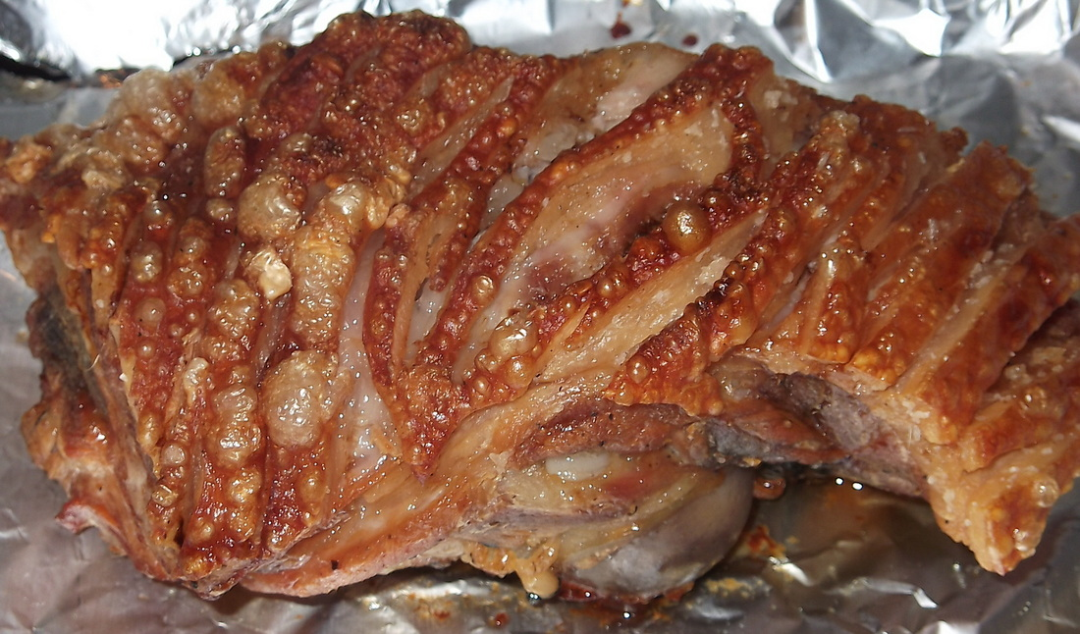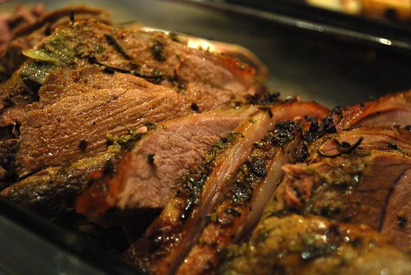

ENTRÉE (choose one option)
Crispy pita breads with homemade dips
Antipasto platter
Savory Tuna salad served with Turkish bread pieces

MAIN MENU OPTIONS (choose two options)
Roast leg of lamb with fresh garlic and rosemary
Red wine and garlic slow cooked lamb shanks
Lamb stir fry on the grill with vegies and fresh herbs
Colombian style pork belly
Succulent roast pork with gravy apple sauce
Simply delicious giant pork souvlaki with capsicum red onion

SIDE DISHES (choose two options)
Cracked pepper roast garlic and rosemary chat potato V GF
Oven roasted seasoned Vegies (potato pumpkin carrots sweet potato)
Fresh herbs oven baked roasted cauliflower with parmesan cheese V GF
Chicken penne pasta with bacon spinach special creamy sauce
Broccoli with bacon fried onions and cracked pepper GF
Cheesy garlic scalloped potatoes GF
Fresh chili garlic green beans V GF
Fried rice or steamed rice GF

SALAD OPTIONS (choose two options)
Mediterranean Tortellini salad red white vinaigrette
Southern style potato salad V GF
Authentic Greek salad V GF
Chefs special cabbage salad
Beetroot and baby spinach feta salad V GF
Seafood crunchy salad V GF
Rainbow coleslaw V GF

DESSERT MENU OPTIONS
Nutella cheesecake with fresh strawberry
Greek mille feuille cake
Chefs special carrot cake
Chocolate hazelnut mouse with fine swiss grated chocolate garnish
Chefs special caramel pecan pie
Chefs special chocolate éclair cake
Wickedly good chocolate Tiramisu cake
Tropical fresh fruit tart with orange custard cream

Buffet menu price includes:
Set up and pack down all food and catering equipment (Buffet tables, chafers, warmers, plates, cutlery etc.
Full set up of buffet tables including cloth with skirting also including complimentary theme decorations
Condiments & dressings including salt & pepper shakers ready on serving station
Stainless steel cutlery, paper napkins, ceramic plates ready on serving stations
Uniformed staff for serving at Buffet station
Clear away all plates cutlery from guest tables
Fresh crusty bread with butter squares
Fruit Platters (GF V v) Using only the best quality season fruit. A perfect finisher for your occasion.

