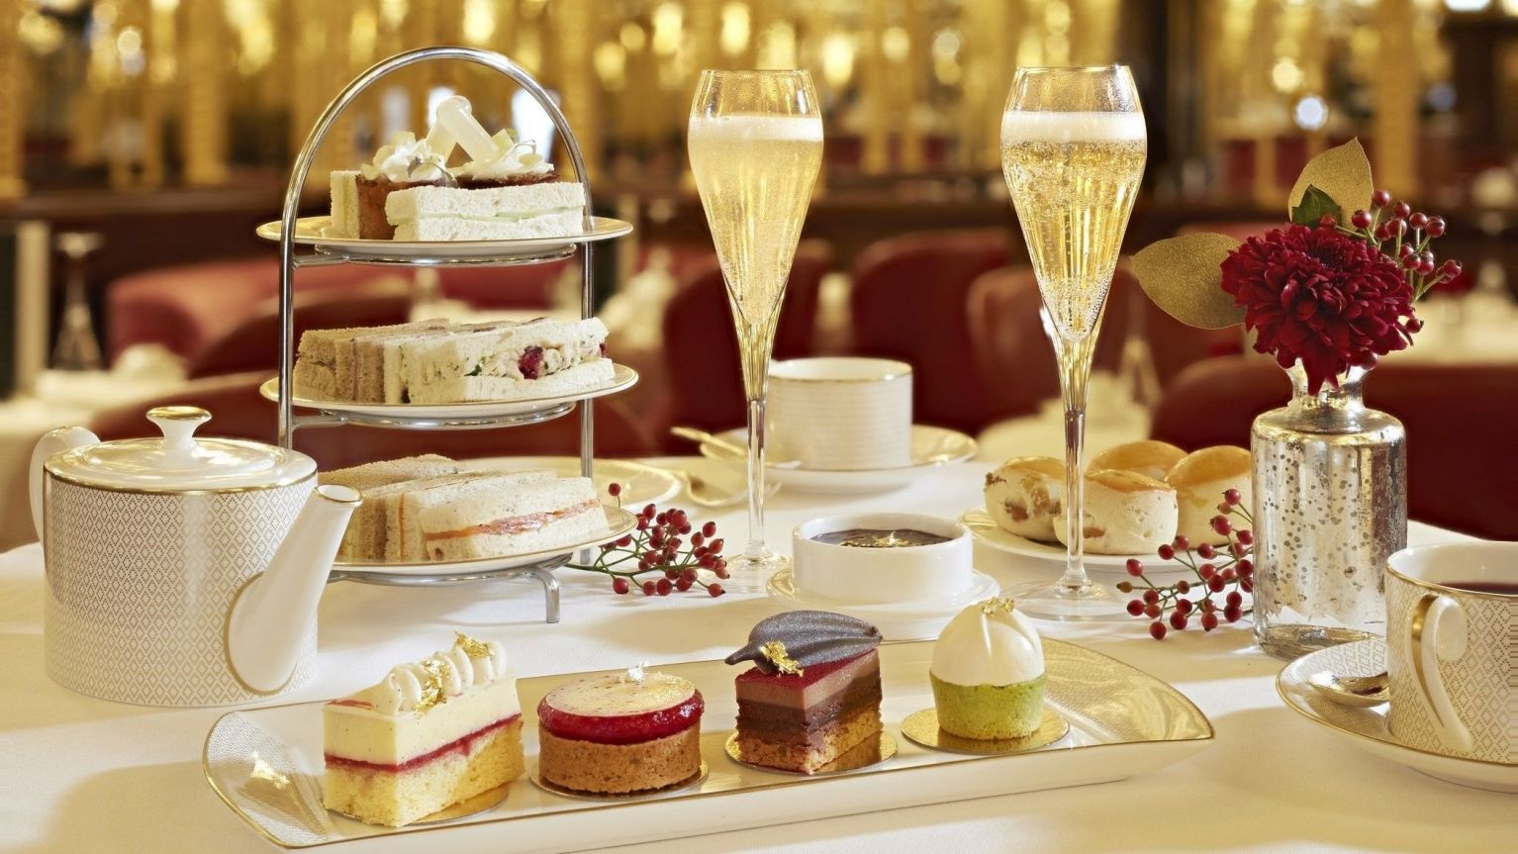 Morning or afternoon tea me

SWEET SELECTION $25.00 (CHOOSE FOUR OPTIONS)
GF = Gluten Free V = Vegetarian v = vegan
Greek mille feuille with chocolate topping V
Freshly baked scone with strawberry jam and whipped cream V
Fresh baked French vanilla and coconut cupcakes V
Tropical fruit kabab sticks V GF v
Lemon cheesecake Mousse cups
Old fashioned rice pudding V GF v options are available
Peanut butter chocolate brownies V
Homemade acai berry bowl V GF v
Yoghurt pots (sweet yoghurt topped with toasted gluten free muesli and fresh berries) V GF

Minimum of 50 people apply.
Customized delivery and staff options available upon request.
Linen, napkins, crockery, side plates and glassware are included.

100% Orange Juice, Iced Water, Tea and Coffee
Both Hot and Cold Selection $39.00

Savory Selection
MORNING TEA OR LUNCH OR AFTERNOON TEA $25.00
(CHOOSE FOUR OPTIONS)

Fresh mini Mediterranean quiche (Gluten free option are available)
Chicken schnitzel sandwich with lettuce swiss cheese and pesto sauce
Avocado tuna salad entertainer rolls
Deli style club sandwiches
House made Cocktail Sausage Roll
Rustic beef and burgundy pie
Spinach puff pastry rolls with ricotta and feta
Oriental platter V GF
Smoked champagne ham & vintage cheddar croissant Smoked champagne ham &
Customized delivery and staff options available upon request.
Linen, napkins, crockery, side plates and glassware are included.
Both Hot and Cold Selection $39.00 Minimum of 50 people apply

Beverages

100% Orange Juice, Iced Water, Tea and Coffee

